**Identification of Common Small Mammal Species in Rustic Cacao Habitat**

**Author: Sara Ash, University of the Cumberlands, Williamsburg, KY**

**Principal Ecological Question Addressed:** What is the composition of a small mammal community within a rustic cacao habitat?

**Student Outcomes**

Upon completion of this experiment, students should:

1. Be able to correctly identify common small mammals of this habitat
2. Be familiar with trapping, handling, and marking methods for small mammals

**Introduction**

A visit to BFREE places you in the midst of one of the most biologically diverse ecosystems in the Western Hemisphere. The Maya Tropical Forest, stretching across southeast Mexico, Belize, and north Guatemala, houses “more than 3,400 species of vascular plants, 60 species of freshwater fish, 42 of amphibians, 121 of reptiles, at least 571 of birds, and 163 of mammals” (Nations 2006). However, this biological wealth is under threat from various factors driven by increasing human population growth in the region. For example, both Guatemala and Belize are expected to double their 2013 human populations by 2050 (Population Reference Bureau 2013). Expansion of agriculture to support growing populations (Tilman et al. 2001) will continue to have devastating effects on biodiversity in this region and across the globe. With expansion of agriculture, portions of the Maya Tropical Forest are expected to change into *countryside*, a landscape dominated by a matrix of farms, agroforestry plots, plantations, gardens, and fallow land (Daily et al. 2001). Embedded within this matrix are varying sizes of natural forest fragments. Daily et al. 2003 argued for more assessment of the conservation value of these human-dominated landscapes.

*Theobroma cacao* (cacao), native to Central and South America, is an agricultural product grown in various tropical climates worldwide. Cacao is typically grown using one of three methods (Figure 1). Of these, conservationists hypothesize that rustic and shaded cacao agroforests will support higher species diversity compared to more intensively managed systems (Rice and Greenberg 2000), and the limited number of studies addressing this question support this (Rice and Greenberg 2000, Schroth and Harvey 2007, De Beenhouwer et al. 2013). A recent global meta-analysis of the biodiversity of both coffee and cacao agroforestry showed that when natural forests were compared to agroforestry systems (rustic and shaded), the decline in species richness was 11%. In contrast, a 46% decline was observed when agroforestry sites were compared to no-shade plantations, with the highest rates of decline in Latin America (De Beenhouwer et al. 2013). Results from 6 years of studying migratory and resident bird species at BFREE in rustic cacao and unmanaged forest habitats have shown significant differences in species abundance although species composition remained much the same (Jacob Marlin, personal communication). On the Smithsonian Migratory Bird Center website, Greenberg wrote about the opportunities for conservation research in cacao agroforestry. He stated that the current scientific literature about biodiversity of cacao farms lacks a comparative focus, thereby limiting application to management of these systems. Comparative research paradigms were suggested to ameliorate this. Specifically, it would be helpful to compare species composition and diversity of cacao farms and alternative farming practices; cacao farms and natural forests; and among cacao farms under different management strategies.

BFREE’s rustic cacao agroforest surrounded by natural forests can serve as an ideal location for comparative research. In January 2015, we initiated a pilot study to compare the small mammal communities between the BFREE’s rustic cacao and nearby forest habitat. We chose small mammals as our focus for several reasons. Small mammals, generally defined as weighing < 1kg as adults and usually including rodents, marsupials and shrews, are important members of the tropical forest community. Studies in the Bladen Nature Reserve (near BFREE) showed that forest spiny pocket mice (*Heteromys desmarestianus)* are significant seed dispersers and predators of tree seeds (Brewer and Rejmanek 1999, Brewer and Webb 2001, and Brewer 2001), thereby influencing plant recruitment. Secondly, vertical stratification of forests is an important habitat component for many species of small mammals. Consequently, this group of animals may be sensitive to differences among the physical structure of cacao management systems and unmanaged forests.

Figure 2 summarizes number of individuals caught in each habitat at BFREE during initial trap cycles in January and June 2015. We identified the small species of rice rats only to genus (*Handleyomys* spp.) because of difficulty in distinguishing them in the field. Other species caught included forest spiny pocket mouse, hispid cotton rat (*Sigmodon hispidus*), Mexican mouse opossum (*Marmosa mexicana*), Coues’s rice rat (*Oryzomys couesi*) and big-eared climbing rat (*Ototylomys phyllotis*).

**Objectives**

For this exercise, you will trap small mammals for at least 3 nights in the rustic cacao grid. You will practice identifying and marking small mammals.

**Prior to field work**

In addition to this guide, your instructor will assign applicable readings for you in preparation for this experiment. You should research the basic biology and ecology of the species that have been previously captured at BFREE (Figure 2). Your instructor will also discuss with you the measures you should take while in the field to maintain your health and safety.



Figure1. Cacao shade management systems (figure directly copied from Rice and Greenberg 2000).

Figure 2. Numbers of individuals of small mammals trapped in January and June 2015 in cacao and forest habitats at BFREE.

**Methods**

Instructors and students of each group participating in this study should read Sikes et al. 2011 which summarizes the guidelines for the use of wild mammals in research.

***Materials and supplies***

Oatmeal

Peanut butter

Soft, mashable fruit or fruit jam

Cheesecloth (optional, enough to make about 300, 4-in squares)

Cotton string to tie bait bags (optional)

Ear tags*

Ear tag applicator*

Thin, leather gloves (e.g. deerskin)

Box of gallon-sized Ziploc bags

Scales*

30 Sherman traps*

Reid field guide*

Data sheets*

Small scrub brushes*

Mild dish soap*

Bleach*

*These items/supplies are available on site at BFREE. Purchase of bait should be arranged with BFREE staff prior to the arrival of your group.

***Study site***

Two trapping grids have been set up in the center of the cacao habitat and approximately 0.5km away in the forested habitat (Figure 3). At each grid, 10 rows of 10 numbered flags were anchored to the ground. Flags were set 7 m apart (Figure 4). If any flags are missing from the grid, please notify a staff member for a replacement flag. **For this exercise, you will trap in the cacao grid only. Additionally, you will set only 30 traps.**

***Baiting the traps***

A single Sherman live trap should be placed at each of 10 flags in rows 6, 8, and 10 of the grids for a total of 30 traps set. Each trap should be baited with a mixture of peanut butter, oats, and mashed fruit or fruit jam. Bait should be mixed in a large mixing bowl the night before and placed in Ziploc bags or back into the empty oatmeal containers. The bait should adhere to itself without being too sticky to handle easily. It should have the consistency of soft oatmeal cookies. Use about a tablespoon of bait for each trap. For easier cleanup at the end of the study, bait could be placed inside a small square of cheesecloth and tied. Place the bait at the back of the trap against the door. Use leaves from the ground to cover the trap to provide some shade.

***Checking traps***

Standardized data sheets should be used to record all the data and will be available on site. One or two group members should be assigned the jobs of recording data and storing data sheets. At the top of each data sheet, record date, name of student group, grid (= partial cacao), and general weather observations from the night before.

Always check the traps in the morning immediately after breakfast. Small mammals can overheat rather quickly in the traps. Additionally, be aware that ants are attracted to the bait and can sometimes kill the trapped mammals. Walk down each row checking for closed traps. WARNING: Occasionally, non-target animals such as birds and/or reptiles are found in the small mammal traps. When checking a closed trap, slowly push down the door just until you can see inside the trap. Do NOT open the door all the way. For open traps, visually confirm the presence of bait. If bait has been removed, adjust the trigger mechanism on the trap and rebait it.

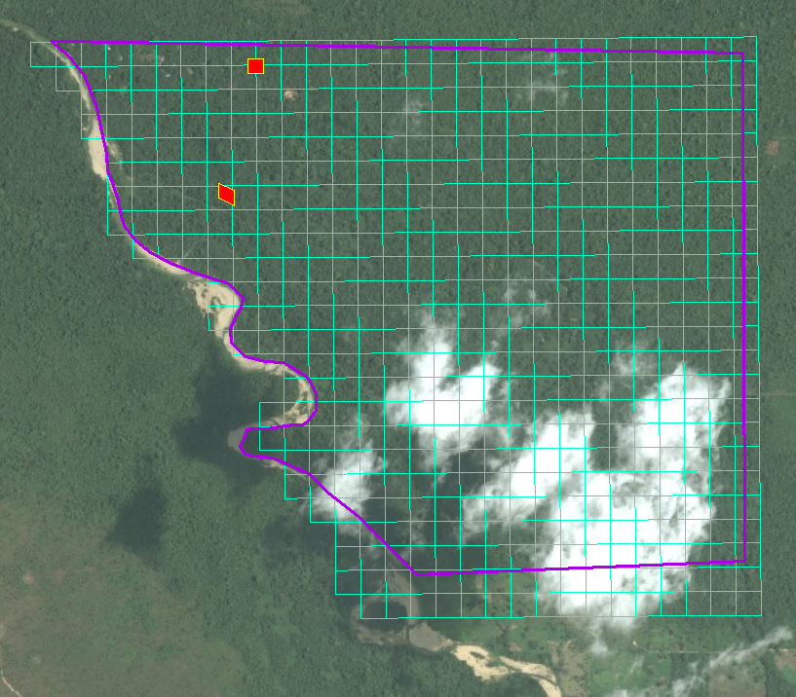

Figure 3. BFREE map (property outline in purple) with location of trapping grids indicated in red. Cacao grid is located approximately 0.5 km north of the forest grid.

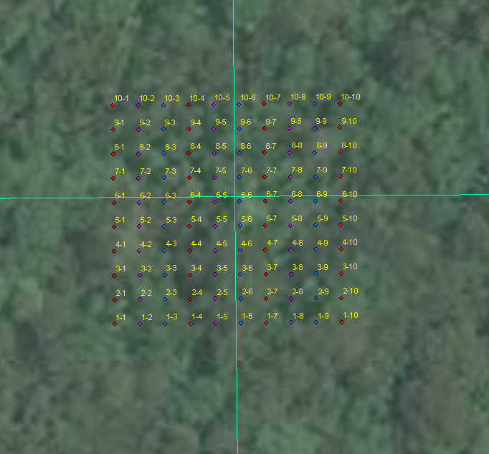

Figure 4. Cacao trapping grid with flag numbers.

***Identifying animals***

For groups with no to little experience with handling wild small mammals, an experienced staff member will be available to assist during animal processing. During animal processing, wrap the Ziploc bag around one end of the trap, open the door through the bag and shake the animal into the bag. Use the Reid field guide to identify the species, if possible. Please note that the *Handleyomys* rice rats are difficult to distinguish. Record the trap number and species. If possible, identify the sex and age through the bag. Age can be difficult to assess, especially for the opossums. Attach scales to the top of the bag and record the mass under the “total” column. Under the “comments” column, record observations about general health, sex condition (descended testes, pregnancy, lactating, etc.) and any other observations you think are important. **It is especially important to look for torn ears, which may indicate the loss of an ear tag**.

***Ear tagging***

If the animal has an ear tag, record its number in the “recapture” column and release it by placing the open bag on the ground. If the animal has no ear tag, one member of your team should load an ear tag into the applicator and record its number in the “tag #” column. For most species, you will need to use the smaller ear tags and applicator. For species with very large ears (e.g. big-eared climbing rat), you should use the larger ear tags and applicator. Following is a link to a video which demonstrates how to properly load the ear tag into the applicator: <https://nationalband.com/products/la-1005-1/>

A second member of your team should place the **closed** bag on the ground and corral the animal toward the corner of the bag. With the non-dominant hand, hold the animal gently against the ground (through the bag). Place the gloved, dominant hand in the bag and pinch the animal at the scruff of the neck and remove from the bag. The first member of your team should pierce the base of the ear with the tag so that the number can be read by looking at the animal’s dorsal surface. Be sure to place the piercing end of the tag beyond a ring of cartilage (Figure 5). Record which ear was tagged (right or left) along with the tag #. For example, if you used tag # 27 in the left ear, record L27 in the “tag #” column. Release the animal.



Figure 5. Placement of ear tag (outlined in red) at base of ear. Proper placement on left and improper placement on right. (Drawing of rat copied from Reid 2009)

Following is a link to a photo of a properly placed ear tag in a small mouse: <http://blogs.millersville.edu/conservation/2012/09/30/more-pictures-from-hawk-mountain/>

***Clean-up on the last day of trapping***

On the last day of trapping, traps should be removed from the grid, cleaned thoroughly and stored in the lab. To clean the traps, remove bait bags and discard. If bait bags were not used, shake out the bait onto the ground. Take the traps to the river crossing and rinse them in the river. Make a mild soap/bleach solution in a bucket. Scrub each trap with the solution, making sure you remove all traces of bait from the trap. Rinse again in the river and shake excess water from trap. Fold the trap and place in boxes for storage.

***Data***

Your group has spent a great deal of time and energy collecting this data. Your data is a small, but important piece of a puzzle that will allow us to better understand small mammal communities. As such, it is important to effectively manage the storage of data. Your class should retain the white data sheet for your own records. Give the yellow copies of the data sheets to a BFREE staff member. Additionally, take a digital picture of each white data sheet as a backup and email these pictures to the author, Sara Ash (sara.ash@ucumberlands.edu). Your data will be compiled with the results of other student groups and made available on the BFREE website.

**Literature Cited and Additional Recommended Readings**

Daily, G.C., P.R. Ehrlich, and A. Sanchez-Azofeifa. 2001. Countryside biogeography: use of human dominated habitats by avifauna of southern Costa Rica. Ecological Applications 11:1-13.

Daily, G.C., G.Ceballos, J. Pacheco, G. Suzan, and A. Sanchez- Azofeifa. 2003. Countryside biogeography of neotropical mammals: conservation opportunities in agricultural landscapes in Costa Rica. Conservation Biology 17(6):1814-1826.

De Beenhouwer, M., R. Aerts, and O. Honnay. 2013. A global meta-analysis of the biodiversity and ecosystem service benefits of coffee and cacao agroforestry. Agriculture, Ecosystems, and Environment 175:1-7.

Greenberg, R. Biodiversity in the Cacao Agroecosystem: Shade Management and Landscape Considerations. Smithsonian Migratory Bird Center. <http://nationalzoo.si.edu/scbi/migratorybirds/research/cacao/greenberg.cfm>

Krebs, C.J. 1998. Ecological methodology. 2nd edition. Benjamin Cummings. 620 pages.

Magurran, M. 2004. Measuring biological diversity. Blackwell Publishing. 256 pages.

Nations, J.D. 2006. The Maya Tropical Forest: People, Parks, and Ancient Cities. University of Texas Press. 285 pages.

Pardini, R., D. Faria, G.M. Accacio, R.R. Laps, E. Madriano-Neto, M.L.B. Paciencia, M. Dixo, and J. Baumgarten. 2009. The challenge of maintaining Atlantic forest biodiversity: A multi-taxa conservation assessment of specialist and generalist species in an agro-forestry mosaic in southern Bahia. Biological Conservation 142:1178-1190.

Reid, F. 2009. A field guide to the mammals of Central America and southeast Mexico. Oxford University Press.

Rice, R.A. and R. Greenberg. 2000. Cacao cultivation and the conservation of biological diversity. Ambio 29(3):167-173.

Schroth, G. and C.A. Harvey. 2007. Biodiversity conservation in cocoa production landscapes: an overview. Biodiversity Conservation 16:2237-2244.

Sikes, R.S., W.L. Gannon, and the Animal Care and Use Committee of the American Society of Mammalogists. 2011. Guidelines of the American Society of Mammalogists for the use of wild mammals in research. Journal of Mammalogy 92(1):235-253.

Tilman D., Fargione J., Wolff B., D’Antonio C., Dobson A., Howarth R., Schindler D., Schlesinger W.H., Simberloff D., and D. Swackhamer. 2001. Forecasting agriculturally driven global environmental change. *Science* 292: 281–284.